**What is Computer Memory? Classify Memory with proper example.**

Computer memory refers to the hardware devices used to store data and instructions temporarily or permanently in a computer system. It plays a crucial role in the functioning of the computer by providing a space for the processor to access and retrieve data quickly.

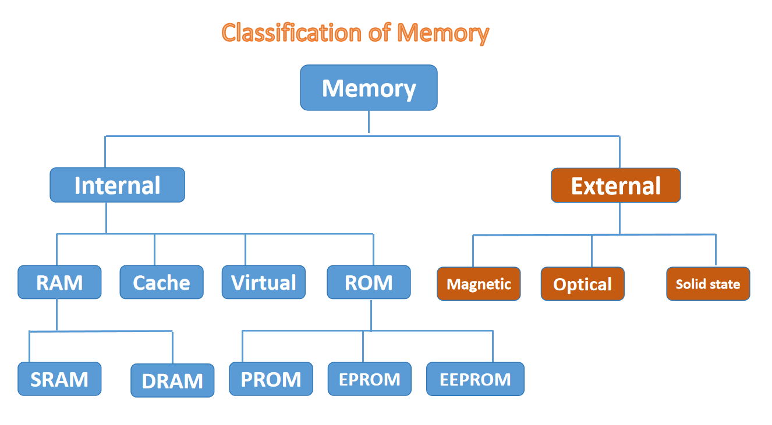

Example:

Internal Memory: RAM and ROM

External Memory: Hard disk, Optical Disk

RAM: Static RAM and Dynamic RAM

ROM: PROM, EPROM, EEPROM

Magnetic: Hard disk, Floppy disk

Optical: CD, DVD Drive

Solid State: Solid State Hard disk

**Define Memory hierarchy**

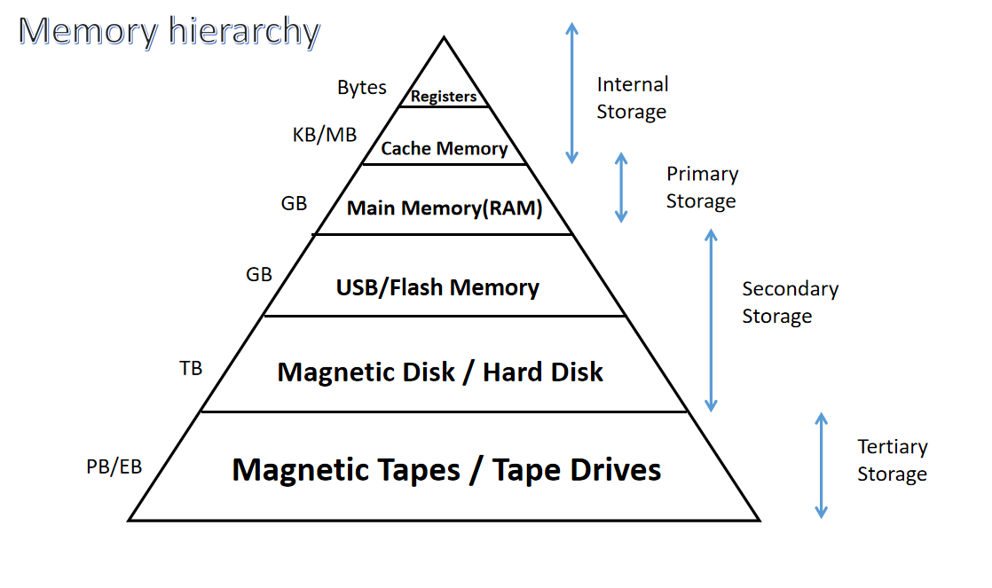

### Memory Hierarchy

The **memory hierarchy** in computer systems is an organizational structure that arranges different types of memory based on their **speed, cost**, and **storage capacity**. This hierarchy is designed to optimize performance and ensure efficient data access. The faster the memory, the more expensive and smaller it is. As you move down the hierarchy, the speed decreases, but the capacity and cost-effectiveness increase.

#### Levels of Memory Hierarchy

**Registers:**

* 1. **Speed:** Fastest
  2. **Capacity:** Smallest (in bytes)
  3. **Cost:** Highest per bit
  4. **Description:** Registers are small, high-speed storage locations directly within the CPU. They store data and instructions currently being processed by the CPU. Examples include the **accumulator** and **program counter**.

**Cache Memory:**

* 1. **Speed:** Very fast (slower than registers but faster than RAM)
  2. **Capacity:** Limited (kilobytes to a few megabytes)
  3. **Description:** Cache memory is a small, high-speed memory that stores frequently accessed data. It helps reduce the time to access data from the main memory (RAM).
     1. **L1 Cache:** Closest to the CPU, smallest in size, fastest.
     2. **L2 Cache:** Larger than L1, slightly slower.
     3. **L3 Cache:** Larger than L2, shared across cores in multi-core processors, slower than L1 and L2.

### Flash Memory

**Flash memory** is a type of **non-volatile memory** that retains data even when the power is turned off. It is widely used in devices like USB flash drives, SSDs (Solid-State Drives), memory cards, and smartphones due to its fast read/write capabilities, durability, and low power consumption.

**Main Memory (RAM):**

* 1. **Speed:** Slower than cache but faster than secondary memory
  2. **Capacity:** Moderate (gigabytes)
  3. **Description:** RAM stores data and instructions that are currently in use by the CPU. It is volatile, meaning data is lost when the computer is powered off.

**Secondary Memory (Hard Disk, SSD):**

* 1. **Speed:** Slower than RAM
  2. **Capacity:** High (terabytes)
  3. **Description:** Used for long-term storage of data, such as files, applications, and the operating system. It is non-volatile, so data is retained when the computer is off. **SSDs** are faster but more expensive than **HDDs**.

**Tertiary Storage (Optical Discs, Magnetic Tape):**

* 1. **Speed:** Slower than secondary memory
  2. **Capacity:** Very large (up to terabytes or petabytes)
  3. **Description:** Used for backup and archival storage. Examples include **CDs, DVDs**, and **Blu-ray discs**.